1. Download and install FireFox
2. Install Selenium IDE addon in FireFox.

<https://addons.mozilla.org/zh-TW/firefox/addon/selenium-ide/>

1. In QM test webapp, login event and go to the photo you want to comment.

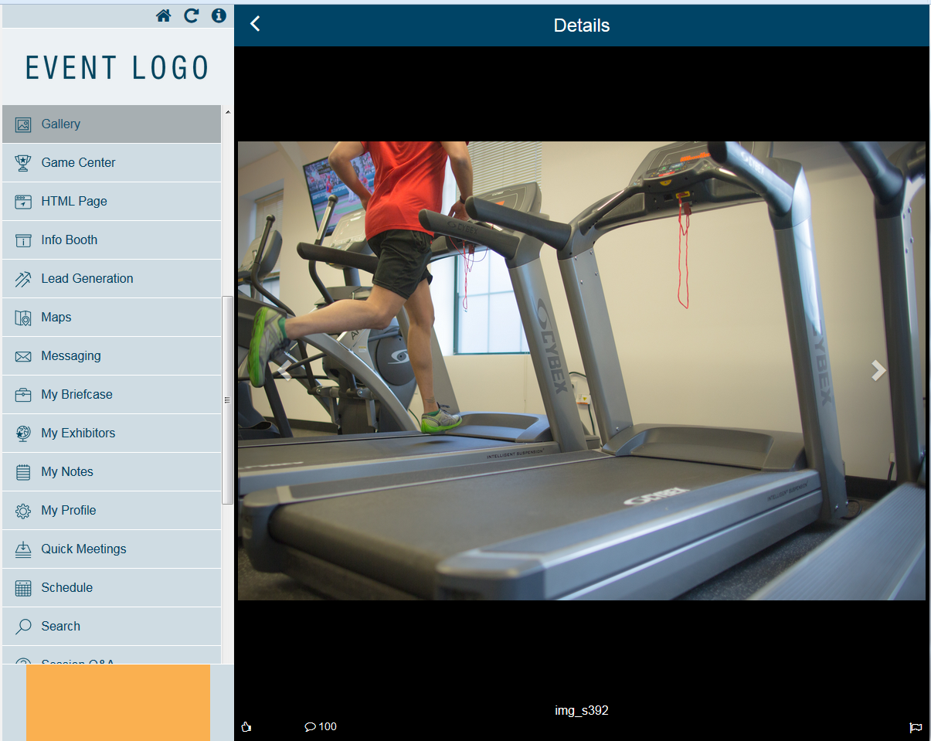

1. Select Selenium IDE.



1. Select File -> Open -> Select the html file I’ve attached.(CommentTest1.html)

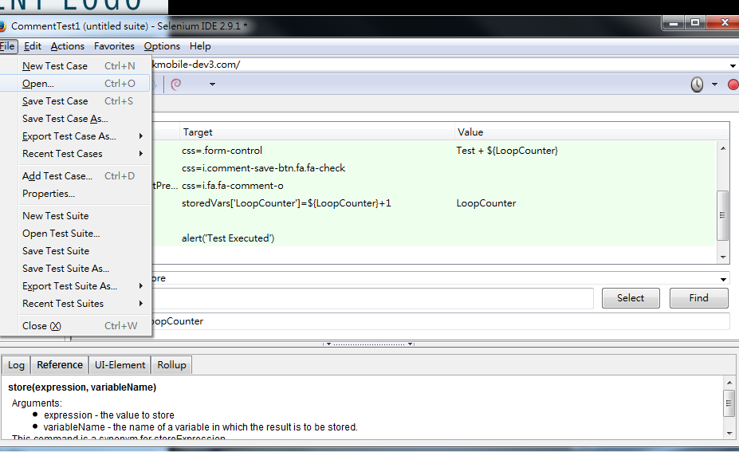

1. Check out the script, change the LoopCount if you need to adjust number of comments.

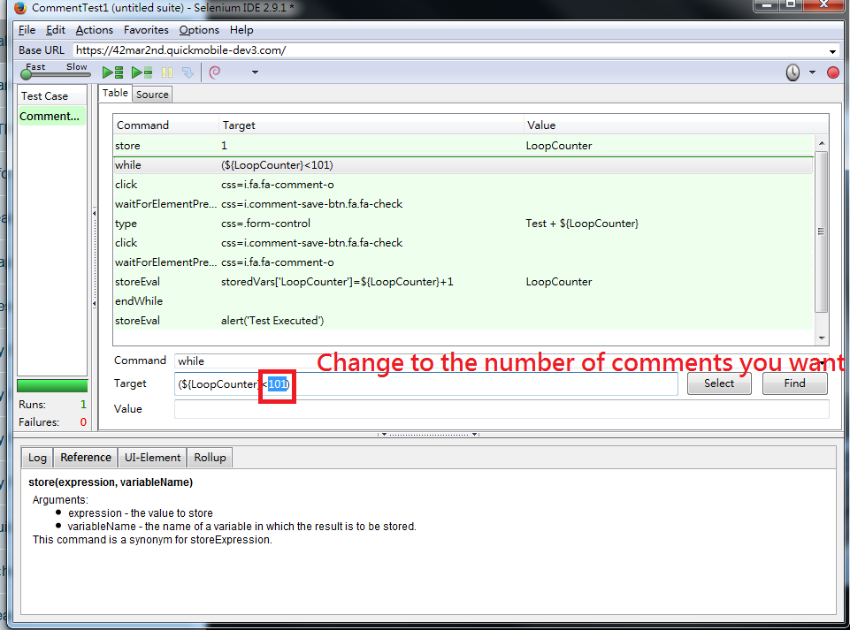

1. Run the script

